**CHATBOT FOR FLAVOR’S**

**Required Resources:**

**Front End:** HTML, CSS, JavaScript, Rivescript (An artificial intelligence scripting language for chatbots and other conversational entities), jQuery

**Back End:** php, sql (For storing Logs)

**Software Requirements:** Visual Studio IDE, phpMyAdmin

Development/Working/Approach:

1. Introduction Phase:

When the customer opens the chatbot on the website, the customer could be anyone of the three:

(a) New Customer

(b) Guest Customer

(c) Registered Customer.

To identify which category the customer belongs to the customer was asked to enter either email or phone number. The entered value was then checked and accordingly they were addressed for instance a new customer was told what the website was about giving them options to explore.

**New Customer**

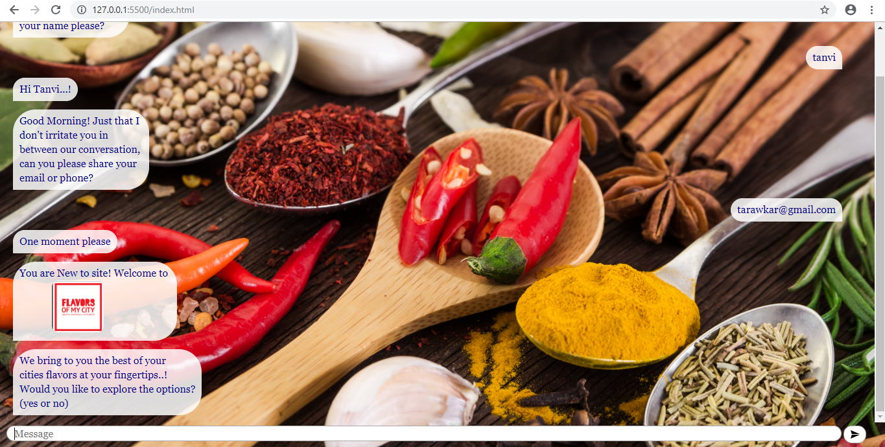

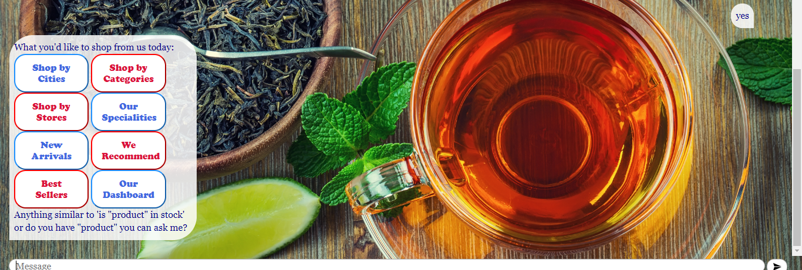

**Registered Customer**

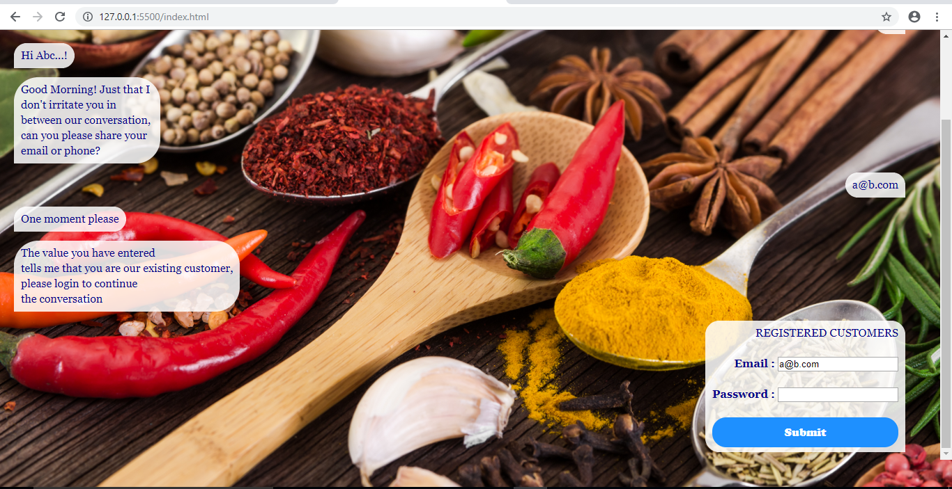

**Guest Customer**

**Customer Queries:**

The chatbot is designed to address the following queries:

**1. How to Login/sign up?**

When a customer wants to know the steps to login or signup to Flavor’s of My City (FOMC), the customer would type a query with word login in it and the chatbot then reads the keyword login looks for it in the rivescript and gives as output:

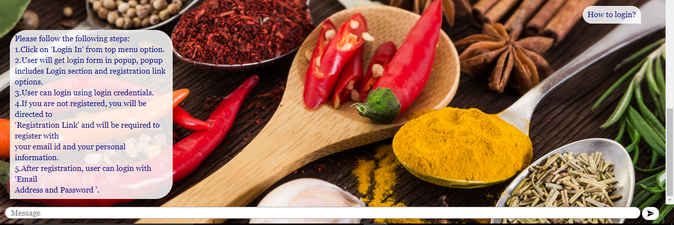

**2. Issues related to login/ Issues related to sign up:**

When a customer is facing issues while login or sign up to FoMC, the customer would type a query with sentence ‘issue while login’ or ‘facing issue while login’. The chatbot reads the word login and looks for it in the rivescript and gives as output:

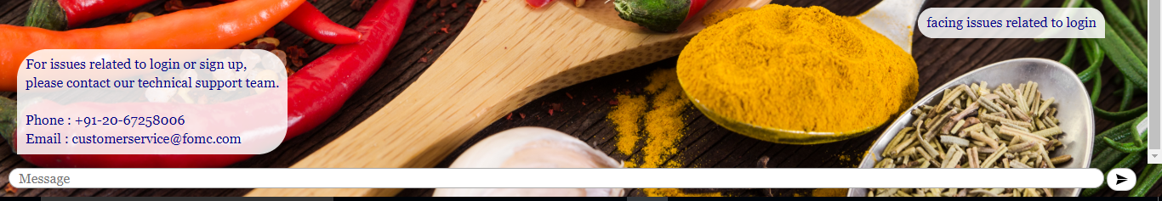

**3**. **Shipping/Delivery:**

When customer wants to know when the order will be shipped/delivered by FoMC, the customer would type a query with sentence ‘when will my order be shipped. The chatbot reads the word shipped and looks for it in the rivescript and gives as output:

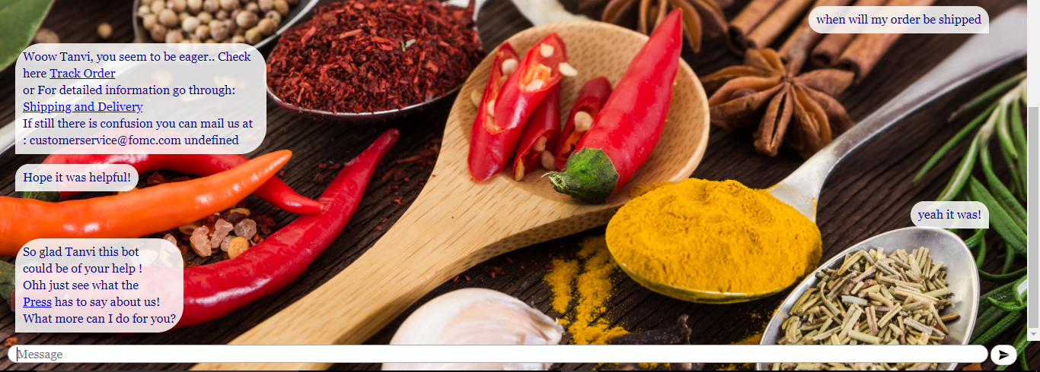

**4. Faq/query/doubt:**

When customer is facing problems with the site or asking questions frequently asked by customers, they are given link to the FoMC FAQ’s. The output is as follows:

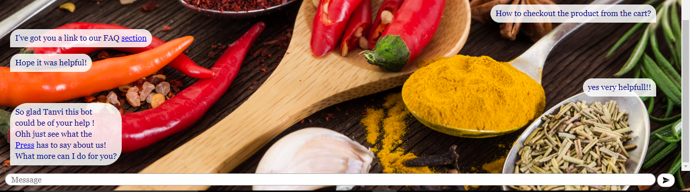

**5. Speciality of city:**

Customers can also search by speciality of city by asking the chatbot: ‘what is the speciality of city_name’ or ‘speciality of city_name’. The chatbot reads the word speciality and looks for it in the rivescript and gives as output:

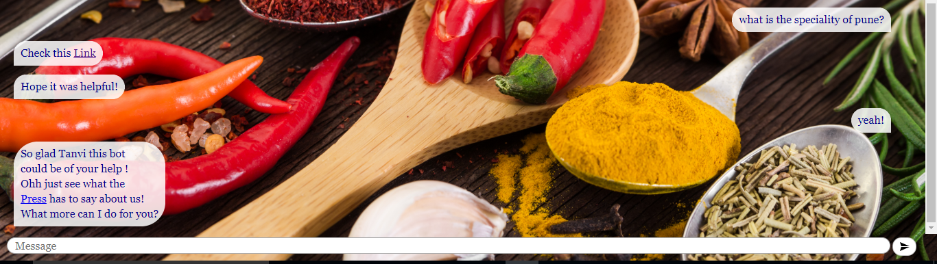

**6. To sell on flavors:**

The chatbot answers people who wish to sell on flavors by looking for the word sell in the rivescript and gives as output:

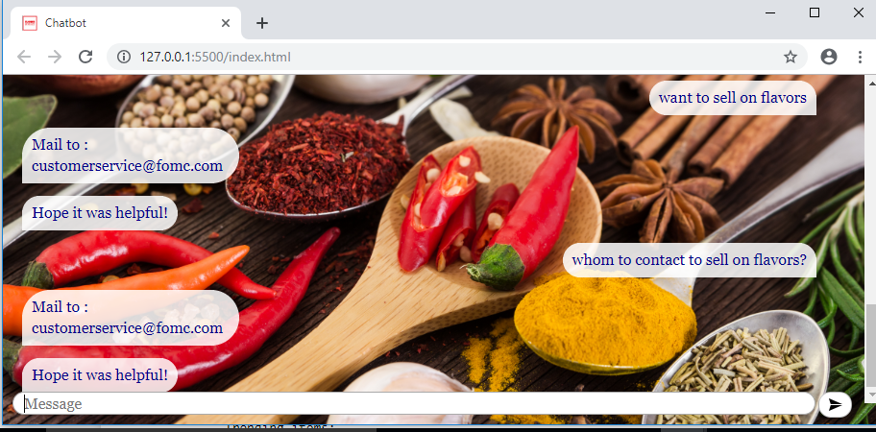

7. Weight of the product

**8. To contact you/reach out to you:**

Customers who wish to contact flavors can do so by asking the chatbot: ‘whom to contact’ or ‘how to reach out to us? ’. The chatbot reads contact / reach out and looks for it in the rivescript and gives as output:

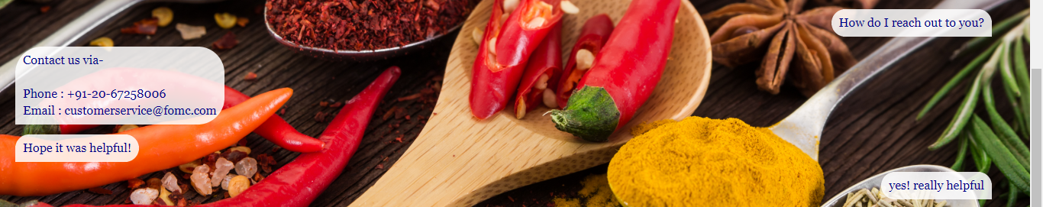

**9. Any offers/coupon code**

The chatbot looks for the word offers or coupon code in rivescript and gives as output:

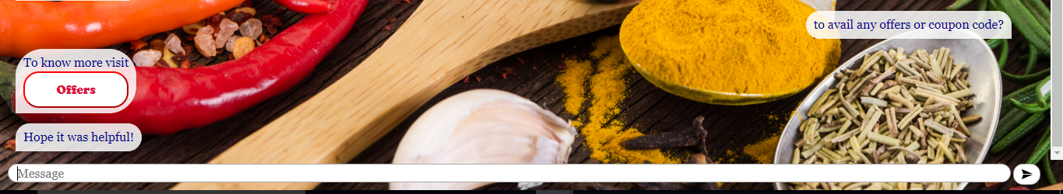

**10. Cancellation / return / rotten**

If the customer wishes to know about cancellation / return policies of FoMC or the order delivered was rotten or open they can questions regarding these to the chatbot. The chatbot looks for the word cancellation / return /rotten in the rivescript and gives as output:

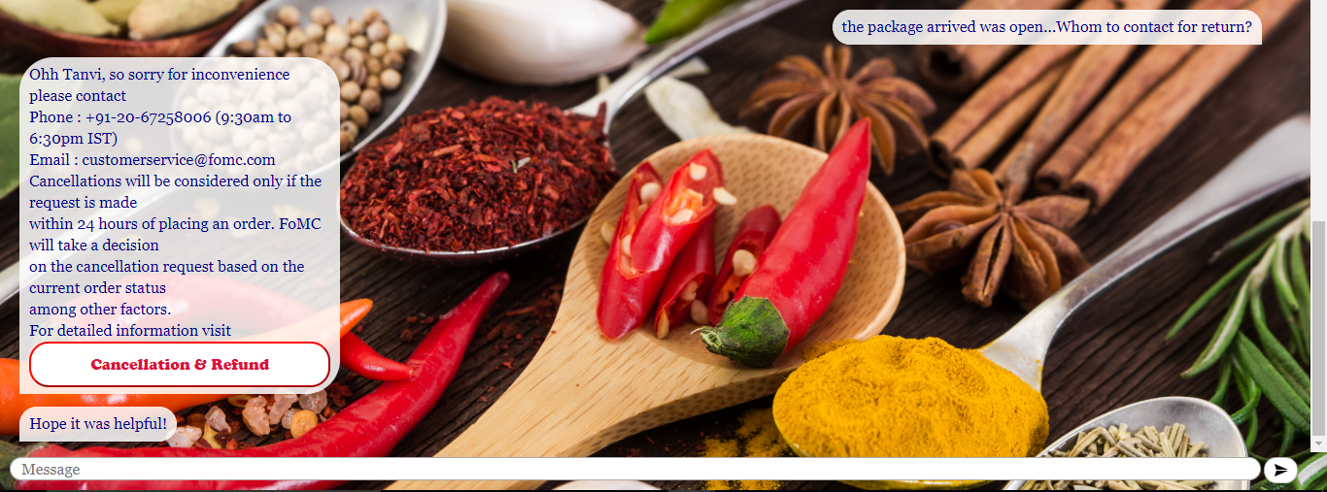

11. Track order

12. Feedback

13. Product search

14. What more to offer (new arrivals)

15. Exit

queries chatbot cannot handle